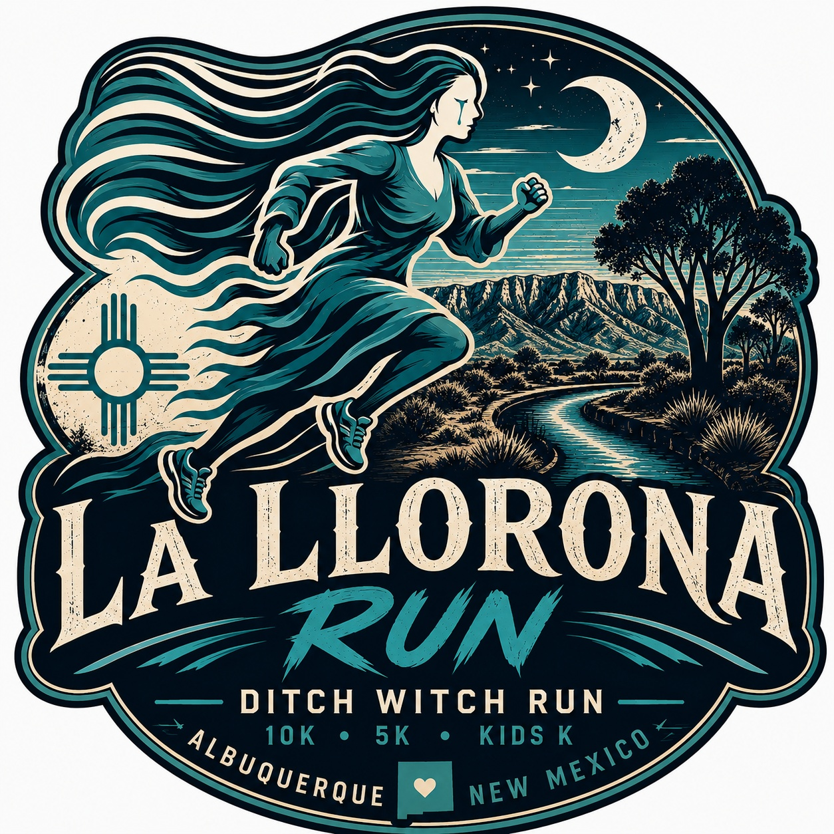

LA LLORONA RUN
EVENT INFORMATION

EVENT LOCATION:
Sagebrush Community Church
6440 Coors Blvd. NW
Albuquerque, NM 87120

EVENT SCHEDULE:
October 11, 2026
10K: 4:00 p.m.
5K: 4:05 p.m.
Kids K: 5:00 p.m.
Costume Contest / La Llorona Storytelling: 5:20–5:45 p.m.
La Llorona Twilight 5K: 5:50 p.m.

*5K “TWILIGHT 5K”: Note: All runners and walkers would need to complete the Twilight 5K no later than 6:50 p.m.
*Run while daylight fades and the legends come alive. Experience the haunting beauty of the Bosque at dusk as shadows lengthen and La Llorona's cries echo through the trees.

"La Llorona Double Dare Challenge"
Already registered for the 10K or 5K? Add the La Llorona Twilight 5K for just $15. You’ll receive a separate bib and official timing and scoring for both races. To sign up, visit the registration table at the event.

PICKUP AND LATE REGISTRATION
Saturday, October 10, 2026

PACKET PICKUP:
11:00 to 3:00 p.m.
FLEET FEET SPORTS
North Towne Plaza
5901 Wyoming Suite R
Albuquerque NM 87109
Please note: We highly encourage you to pick up your packet at Packet Pickup to avoid lines and guarantee your shirt size. Any out-of-town participants may pick up their packets on race day: 2:45-3:30 p.m. at the event.
START:
La Llorona Race Day Registration will be located on the north side of Sagebrush Community Church. NOTE: ALL PARTICIPANTS MUST WEAR A TIMING CHIP, LOCATED ON THE BIB. PLEASE DO NOT REMOVE OR ALTER IN ANY WAY.

PARKING:
Sagebrush Community Church
PLEASE USE DESIGNATED PARKING AREAS/SPACES ONLY.
BATHROOM FACILITIES:
Port-a-potties are located near the start/finish. Please allow plenty of time to use the restroom.
START INFORMATION:
All races will start promptly at the designated times listed above. Allow plenty of time to get to the Start to seed yourself according to your projected pace; if you are driving to the race, plan to arrive early. See parking information above.
This race is a Gun Start with a Timing Chip finish. The "official time" will start when the gun/horn goes off.
RACE (BIB) REQUIREMENTS:
Each participant will receive a Race (Bib with timing chip) number that must be worn on race day. DO NOT alter your race number in any way. Your bib number must be visible and worn on the front outside of all clothing during the entire race so that it may be seen. Bib numbers are non-transferable and MUST be worn by the runner to whom it is assigned.
MEDICAL SUPPORT:
Medical staff members will be ready to assist you at any time. Radio communications personnel will be positioned along the course at every aid/water station.
The event officials have the right to withdraw any runner from the race who appears distressed or at risk. If you have a health or medical problem at the Finish Line, please notify event officials or volunteers. Please cooperate if you are asked to go for a checkup. If you need help at any point, please ask for it! If you cannot finish the race, please notify a race official of your bib number so that the medical personnel know.
FREQUENTLY ASKED QUESTIONS:
Can I run with iPod/headphones?
Yes. USATF, the sport's national governing body, recently amended its headphones, iPods, and similar devices ban. However, athletes competing for prizes cannot use electronic devices such as headphones and earpieces.
Can I run with my Garmin GPS or my Nike Plus device?
Yes, participants may wear their Garmin GPS watches and Nike Plus devices. However, these items do not count as "second-timing devices" and will not be recognized by the event as official times or distances.
What is NOT allowed on the course?
The use of video devices, cell phones, computers, cameras, or any similar devices by participants in the event is prohibited. The use of wheeled devices by participants or any other person authorized to be on the course shall be strictly limited to: (a) authorized course marshals on bicycles. Baby joggers, strollers, skateboards, rollerblades, unauthorized bicycles, or other wheeled devices will not be permitted.
Do you have a Lost & Found case? I lost something at the Event or on the racecourse.
Yes. We will have a Lost & Found for lost and found items on race day. If you are missing a personal thing, please call 505.217-4774.
I am injured and cannot run the event (family commitment, work obligation, etc.). Can I get a refund, donate my entry, or transfer my access to someone else?
No. The sale and transfer of race entry/bib are strictly prohibited, resulting in disqualification and banning any individuals involved from future events. All entry fees are non-refundable and cannot be deferred toward a future event.
If I provide medical documentation of my injury or pregnancy, will you refund me?
No. Please refer to our official event rules and guidelines.
Can I defer my entry to next year if I cannot run this year?
Participants cannot defer their entries to the next year if they cannot run.
Can a friend pick up my packet if I cannot attend Packet Pickup?
Yes. Your friend can pick up your packet for you.
Am I able to bring my dog?
No! Due to the single-track nature of the course in some areas, dogs are not permitted. Please leave your dog at home.

INCLEMENT WEATHER POLICY:
Weather forecasts will be monitored before the event, paying particular attention to the possibility of heavy rain, thunder and lightning, high winds, and extreme temperatures. If necessary, athletes will be made aware of these predictions on the RunFit website: www.irunfit.org, so that participants can properly prepare for severe weather during the race and possible course alterations. Severe weather updates will also be sent to participants via email as necessary. The Race Director will monitor the weather and decide if any action will be required to modify the race. Possible changes include altering the start time for the race or, in extreme situations, cancellation of the event. Please listen closely to all public address announcements at the race's starting line. Visible lightning will cause the race to be postponed for a minimum of 15 minutes. Additional sightings will continue to delay the race in 15-minute increments. If extreme heat is predicted, the athletes will be provided extra water before, during, and after. The medical team will be alerted that athletes may require additional medical attention during and after the event due to the high temperatures.
FINISH INFORMATION:
The overall and division award winners will be announced at the Awards Ceremony on race day – immediately following the Kid K.

10K Awards
Overall prizes will be awarded to the top three male and female finishers, determined by gun time.
Age-group prizes will be awarded to the top three male and female finishers in the following categories:
19 and under, 20–24, 25–29, 30–34, 35–39, 40–44, 45–49, 50–54, 55–59, 60–69, 70+.

5K & Twilight 5K Awards
Each 5K event will have its own separate overall and age-group awards.
Overall prizes will be awarded to the top three male and female finishers in each event, determined by gun time.
Age-group prizes will be awarded to the top three male and female finishers in each event in the following categories:
12 and under, 13–15, 16–19, 20–24, 25–29, 30–34, 35–39, 40–44, 45–49, 50–54, 55–59, 60–69, 70–79, 80+.
All awards will be determined by gun time.
Double Dare Participants: Participants completing both the 5K and Twilight 5K are eligible for overall and age-group awards in each event based on their individual race results.

KIDS K:
All registered participants (11 and under) are eligible to participate in Kids K. The start of Kids K will begin at 5:00 p.m. immediately after the 5K and 10K.

POST RACE:
Refreshments and Awards

REVIEW THE COURSE AND SUPPORT:
Decide where your family and friends can cheer you on when you most need support.
There are fluid replacement stations: Water (5K & 10K) and Water & Powerade (10K).

COURSE:
5K - 10K: Most of the course will be on the Bosque ditch banks and trails. Courses will be well marked along with volunteers and aid stations.

COURSE LINKS: (CUT AND PASTE LINK IN BROWSER)
5K: LA LLORONA "DITCH WITCH" RUN 5K - MapMyRun
10K: LA LLORONA "DITCH WITCH" RUN 10K - MapMyRun
Results: All results will be posted immediately at: www.irunfit.org
VOLUNTEER INFORMATION:
Volunteers are still needed to help! Please contact RunFit at (505) 217-4774 to volunteer for race day or email: stephenpino@hotmail.com.
THANK A VOLUNTEER CAMPAIGN:
The Ditch Witch "La Llorona" Run is fortunate to have some of the friendliest and hardest-working volunteers around. Volunteers help us on race day to ensure you feel welcome, are fully informed, have a safe, prosperous, and positive running experience, and more! When you have a chance, give hearty, fun-loving thanks!
SPONSORS:
We would like to thank the following sponsors for their support: Fleet Feet Sports, New Balance, Heart and Sole Sports, PNM, Infinity Fitness, Pen Pals HVAC, ASRT, Express Flooring, Gonstead, Great Harvest Bread, Coldwell Bank Legacy, Por Vida Therapeutics, Powerade, and NM Flooring Solutions.
RACE QUESTIONS AND INFORMATION:
RunFit
12104 Palm Springs Ave. NE
Albuquerque, NM 87111
(505) 217-4774
Email: stephenpino@hotmail.com RunFit Website: www.irunfit.org

